Morne du Toit

GYGVF2448

**Lecturer: Micheal Duve**

**March/April 2021**

ITECA3  
Deliverable 2

# Documentation & Coding

**Student name:** Morne du Toit

**Student Number:** GYGVF2448

**Project Title:** Hout E-Commerce

**Submission Date:** 25 June 2021

# Table of contents

Documentation & Coding **1**

Table of contents **2**

**2.1 Introduction** **3**

**2.2 Prototyping** **3**

2.3 Designing **16**

2.4 Coding **21**

2.5 Conclusion **27**

**2.6 Sign-off** **29**

# 2.1 Introduction

The client runs a small furniture business, called Hout, in which he locally manufactures his furniture, in the past, he would sell his products at local markets which would result in the client receiving a small profit margin. However, he would like to expand his business by first selling domestically and then globally, ensuring that the client maximizes their profits.

He plans to hire more staff to help him, but first, he would need to advertise to a new extension of customers, which currently seems impossible. Nevertheless, the client has decided to expand his business with an e-commerce site.

# 2.2 Prototyping

Provide the screenshots of the two responsive prototypes asked in the project specification document. Each prototype must illustrate how all the pages of the website will be displayed on smartphones, tablets, and desktops.

1. **Prototype 1**Home  
   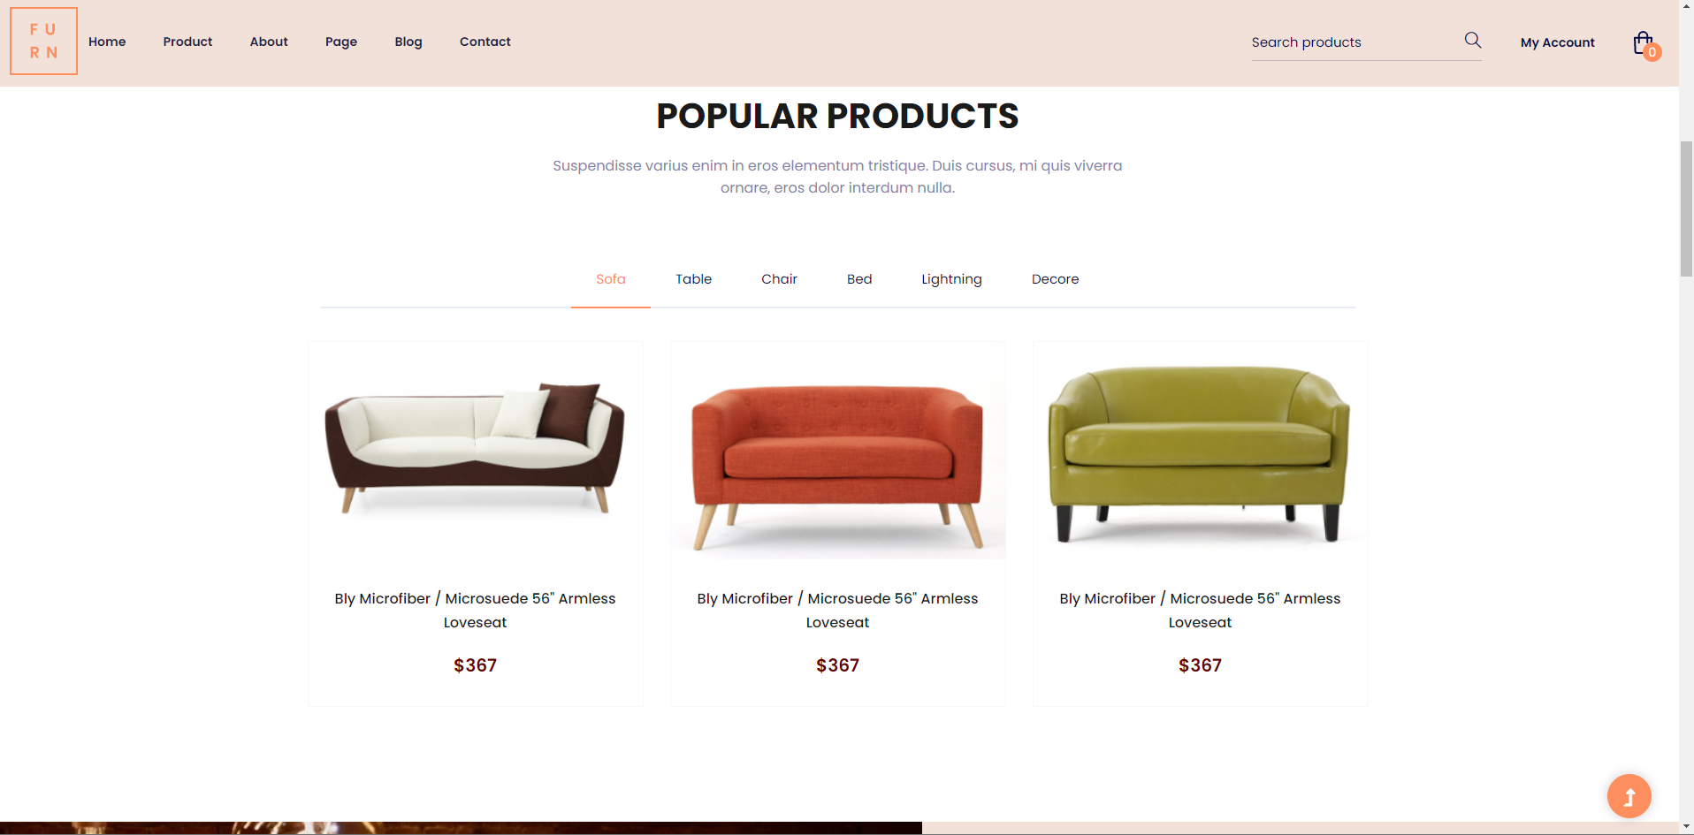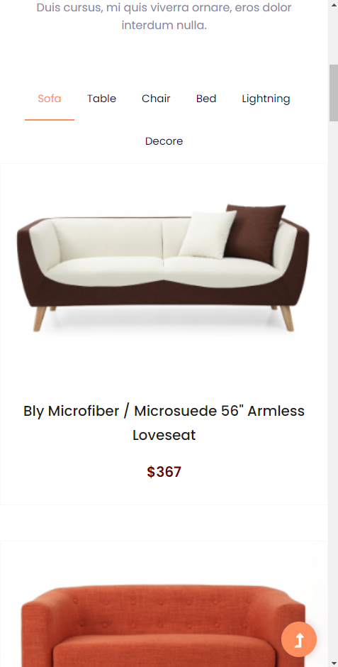  
   Contact  
   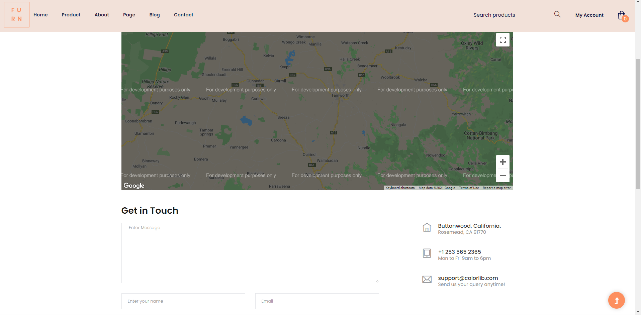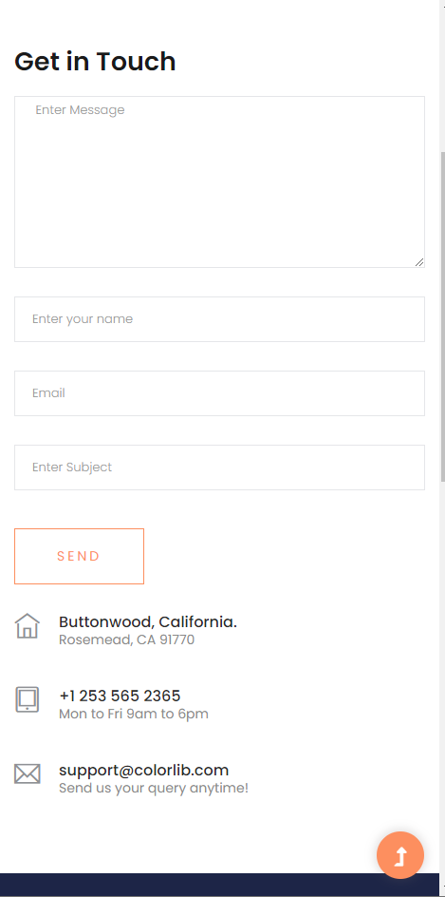  
   Product  
   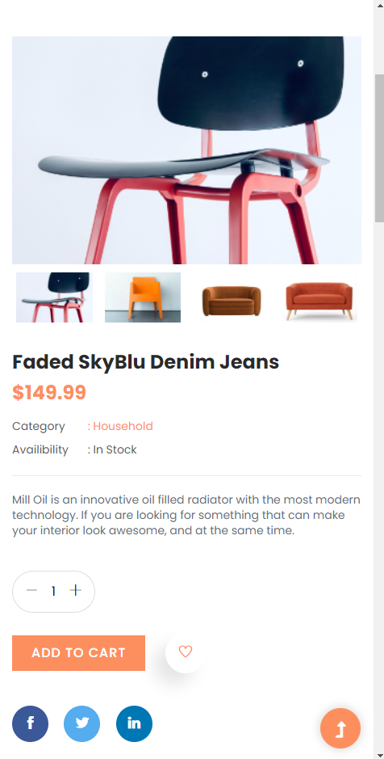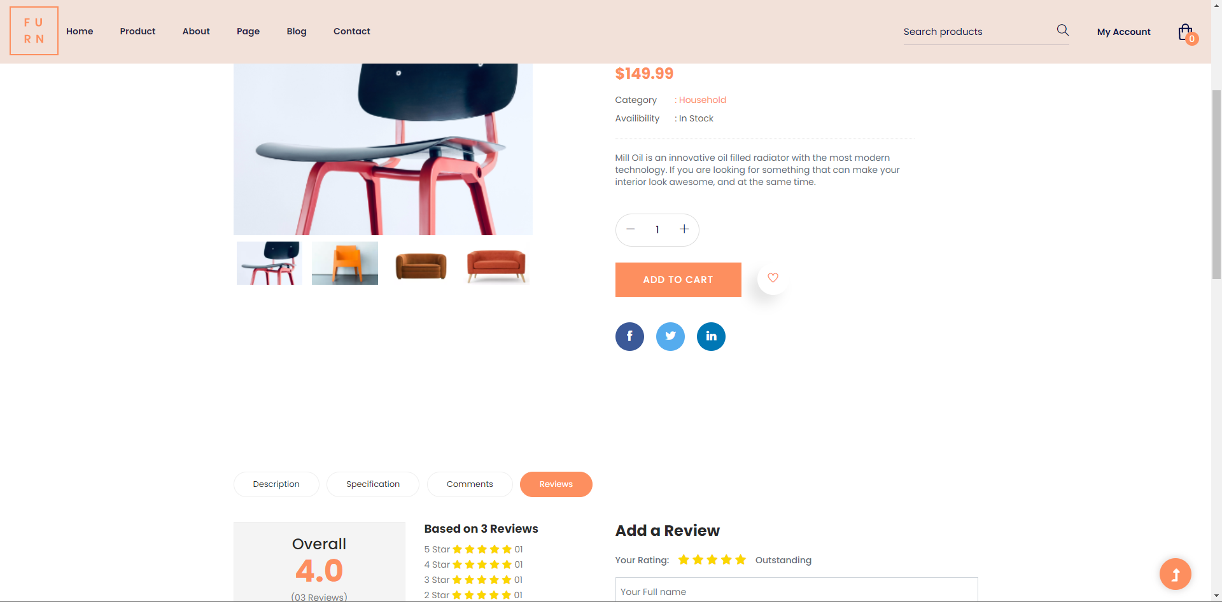
2. **Prototype 2 (Client selected Prototype 2)**Home  
   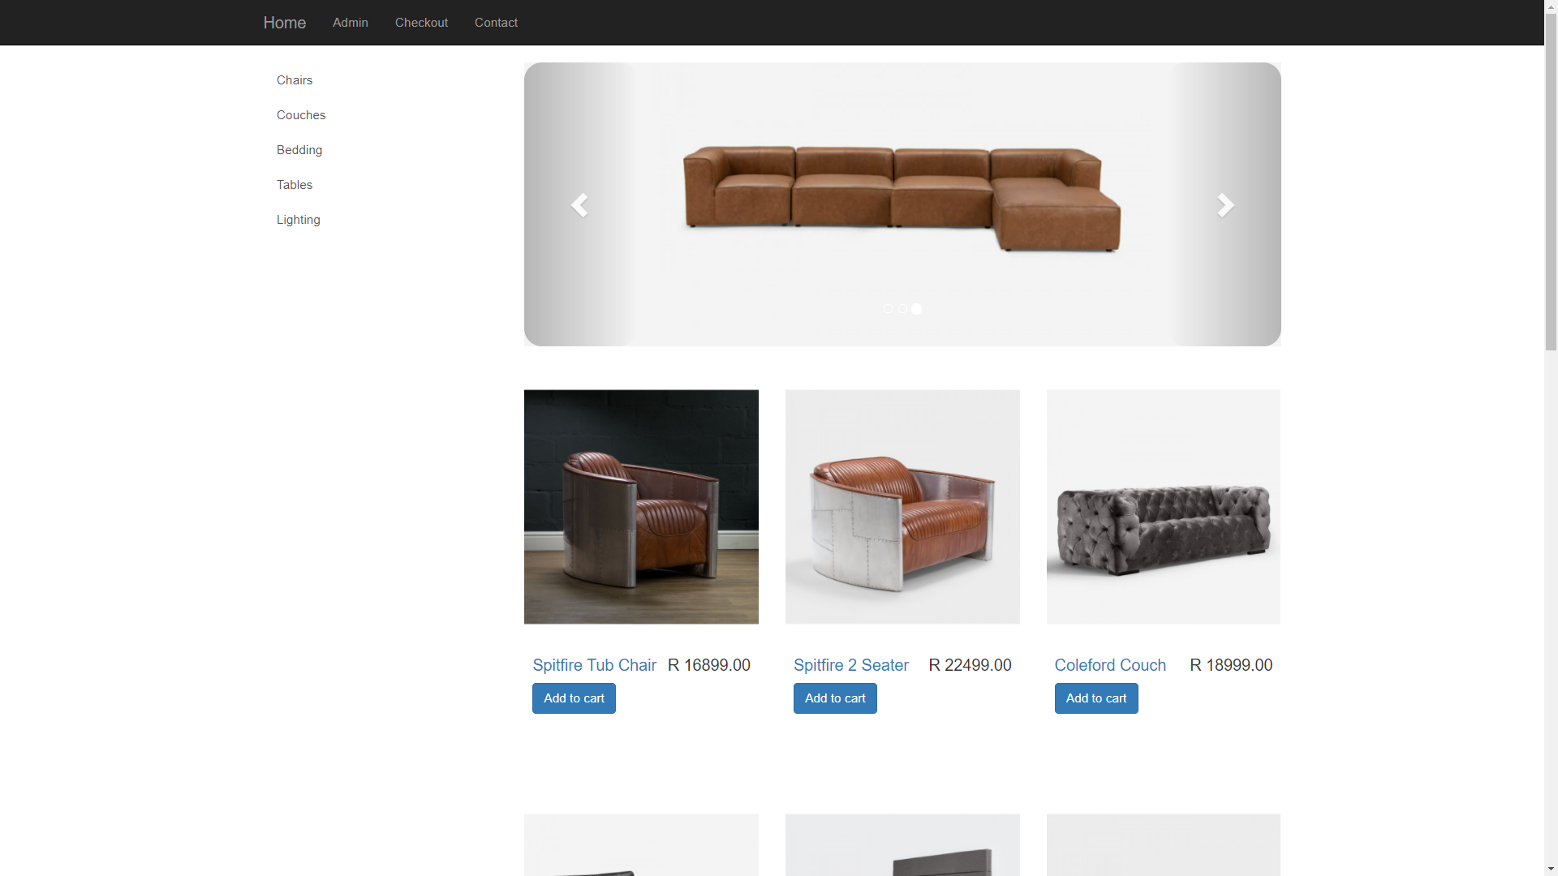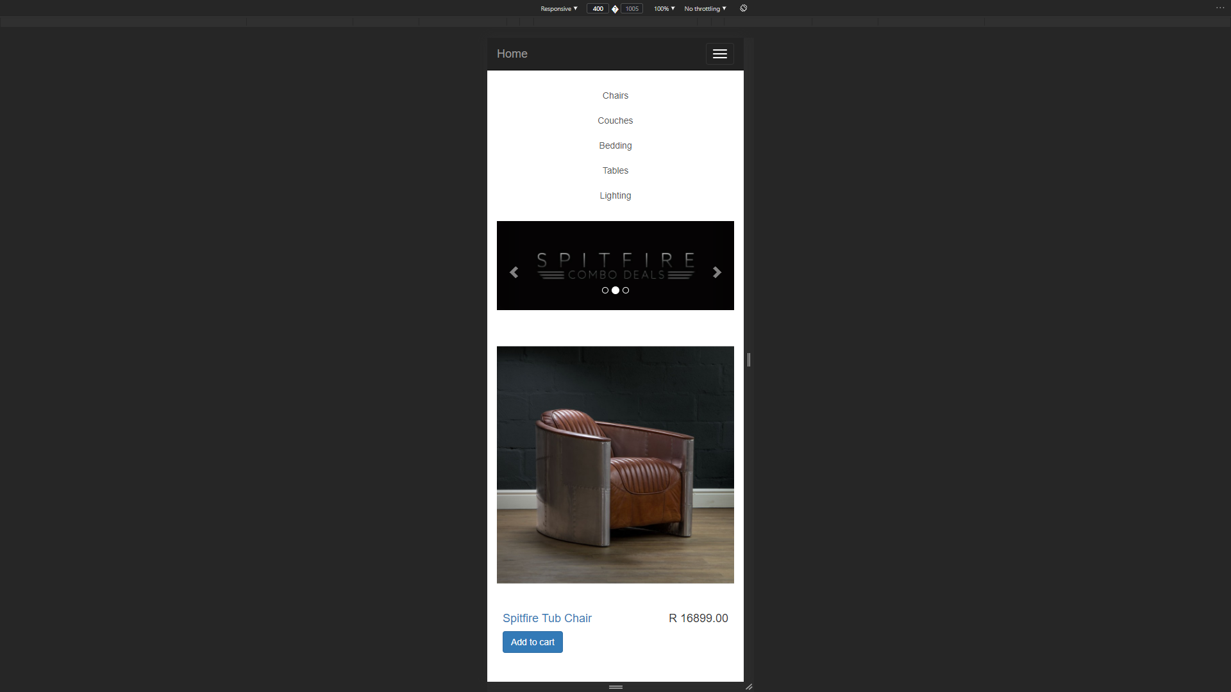

Product

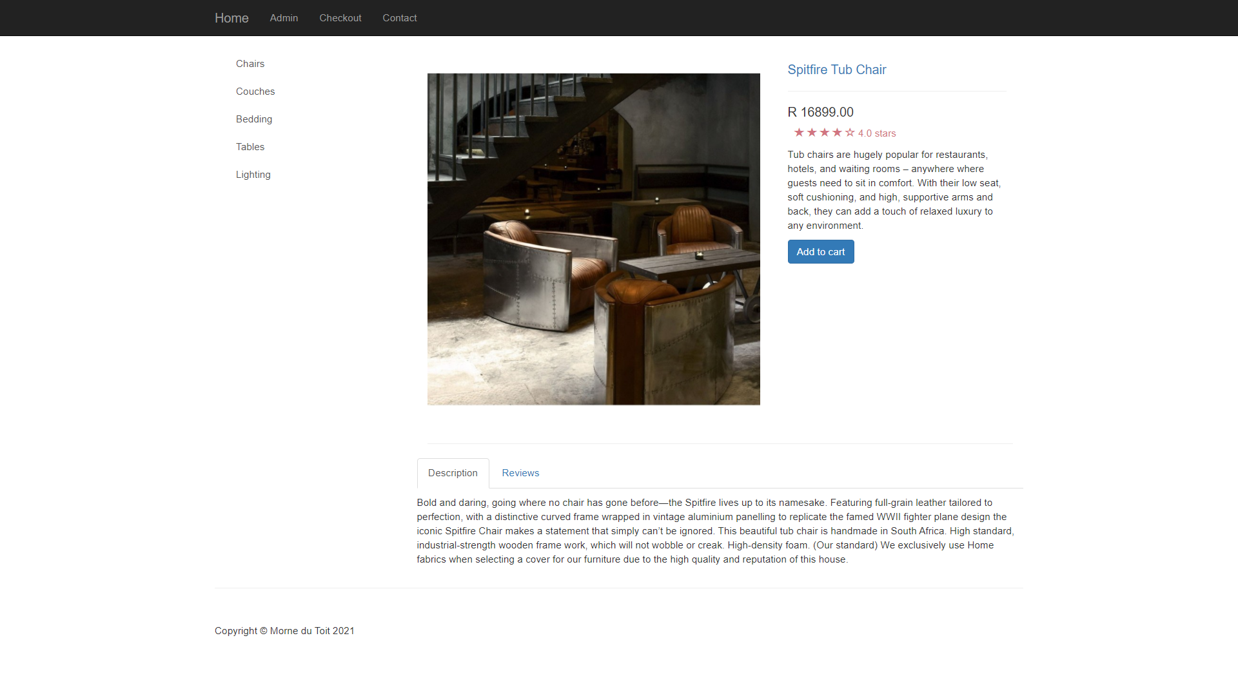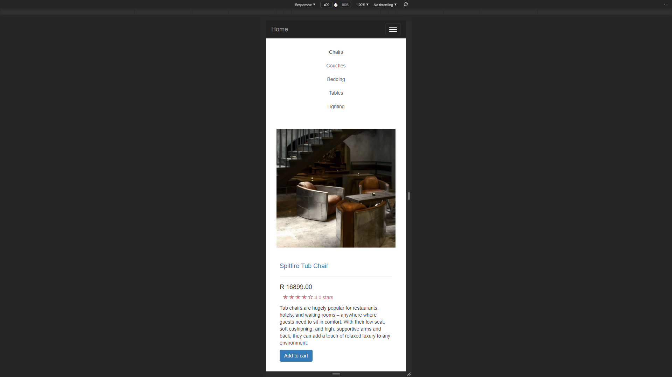

Categories

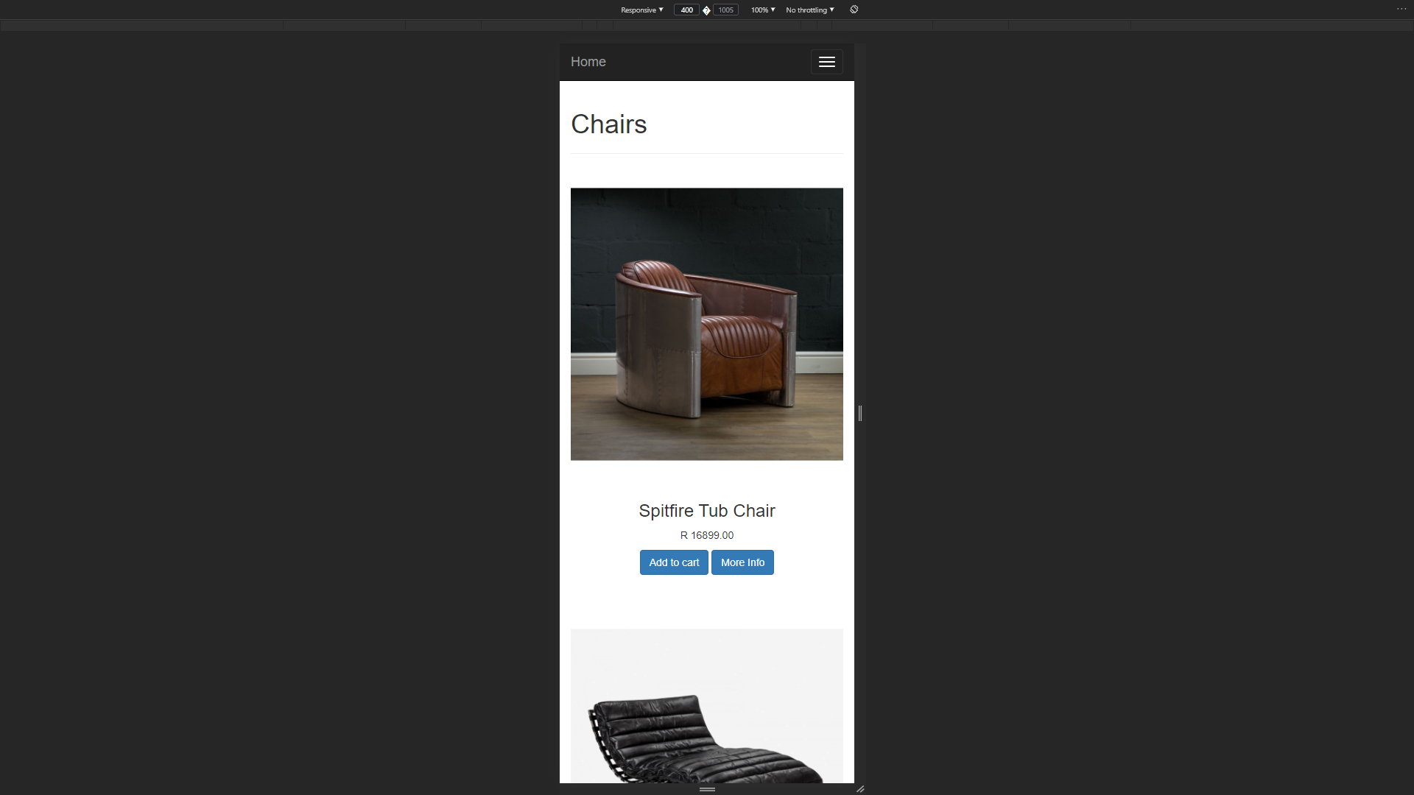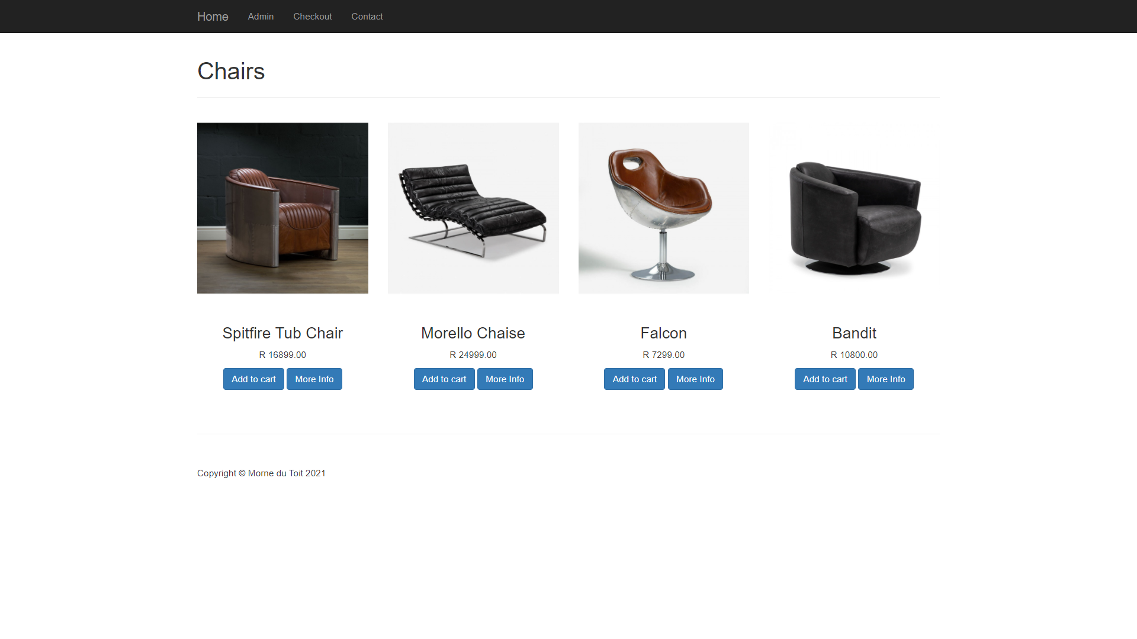

Checkout

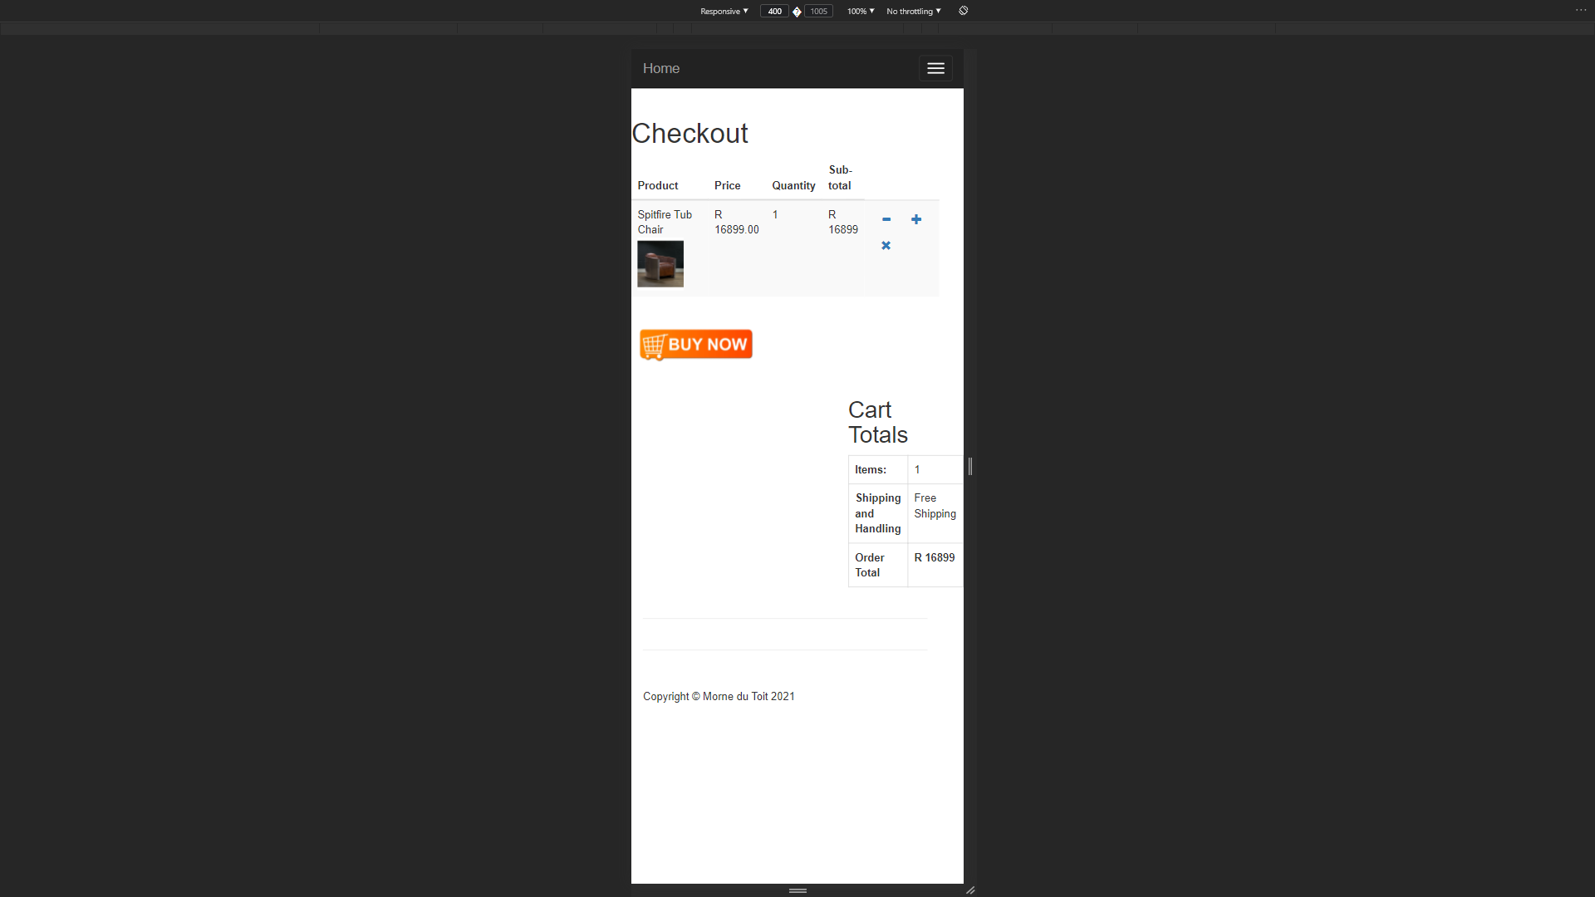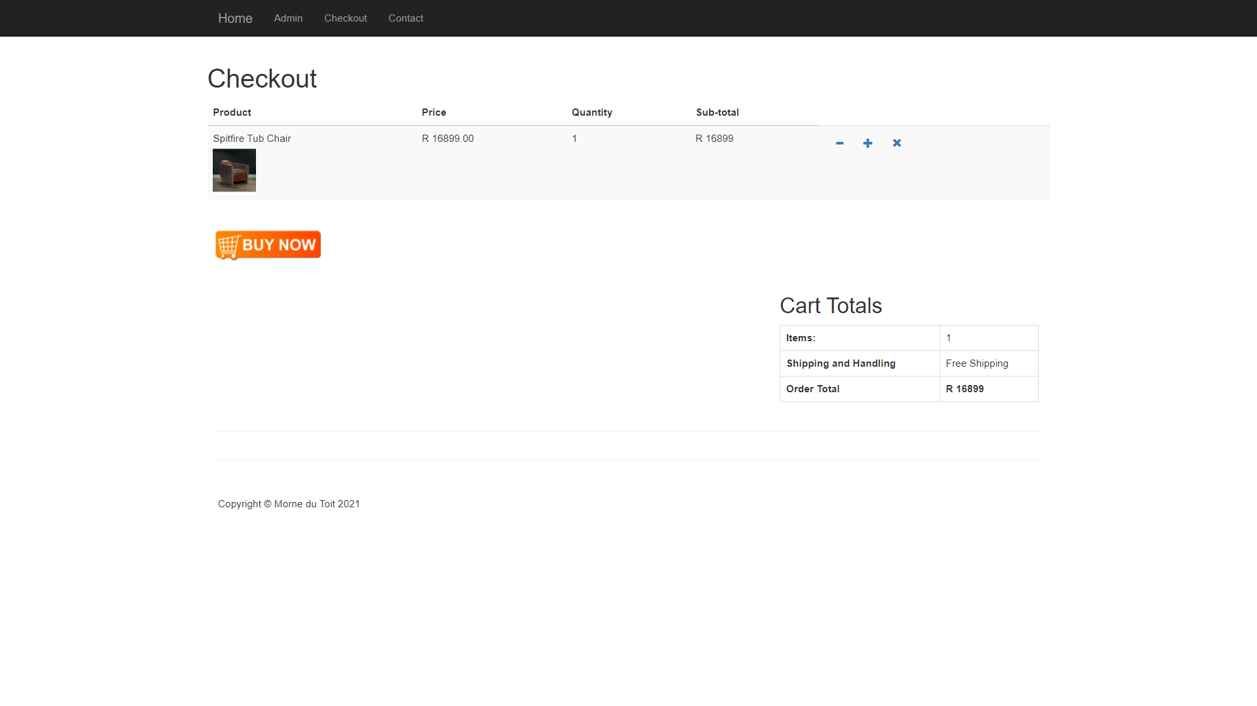

Contact

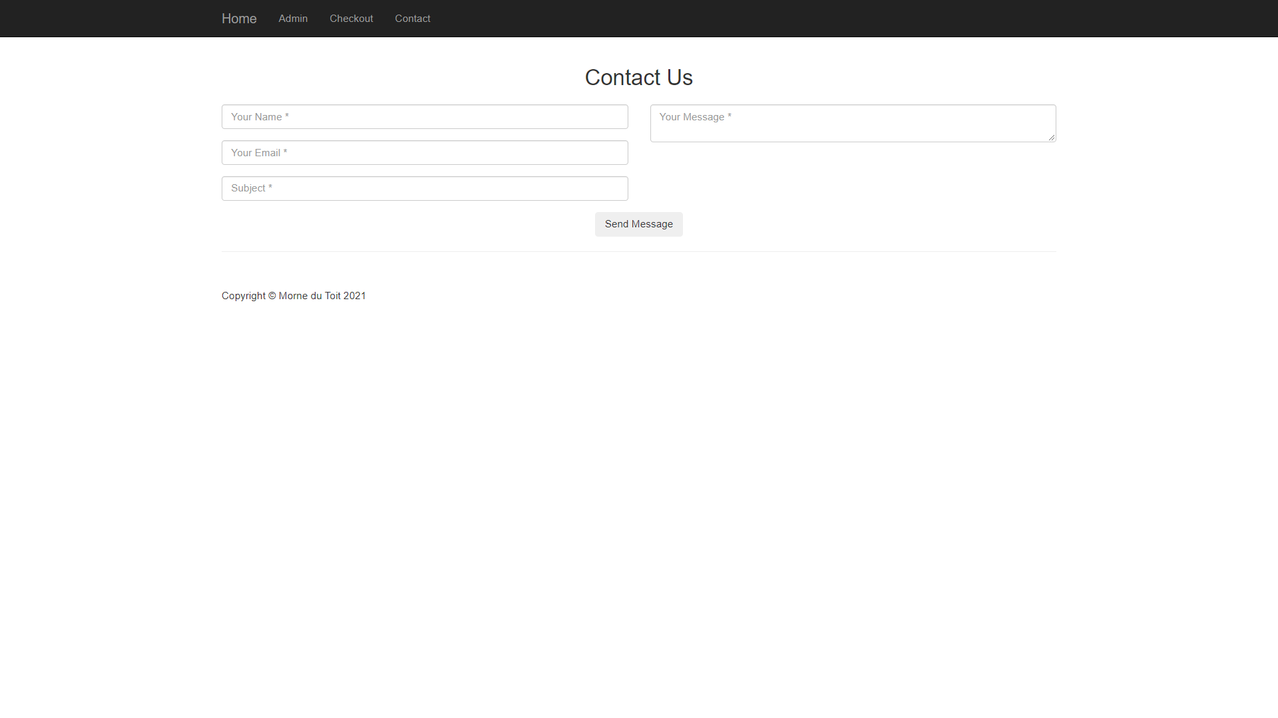

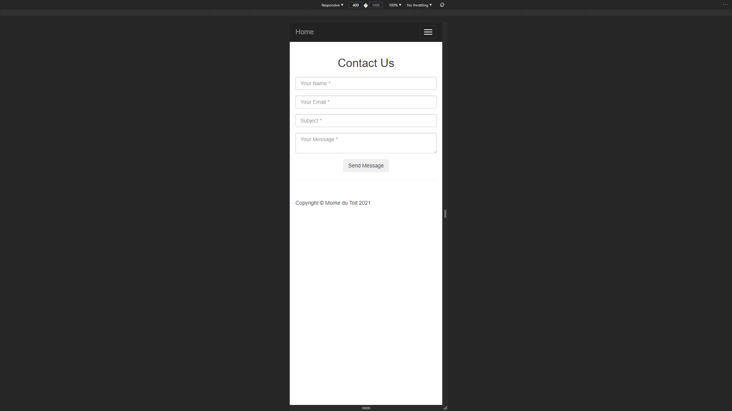

Login

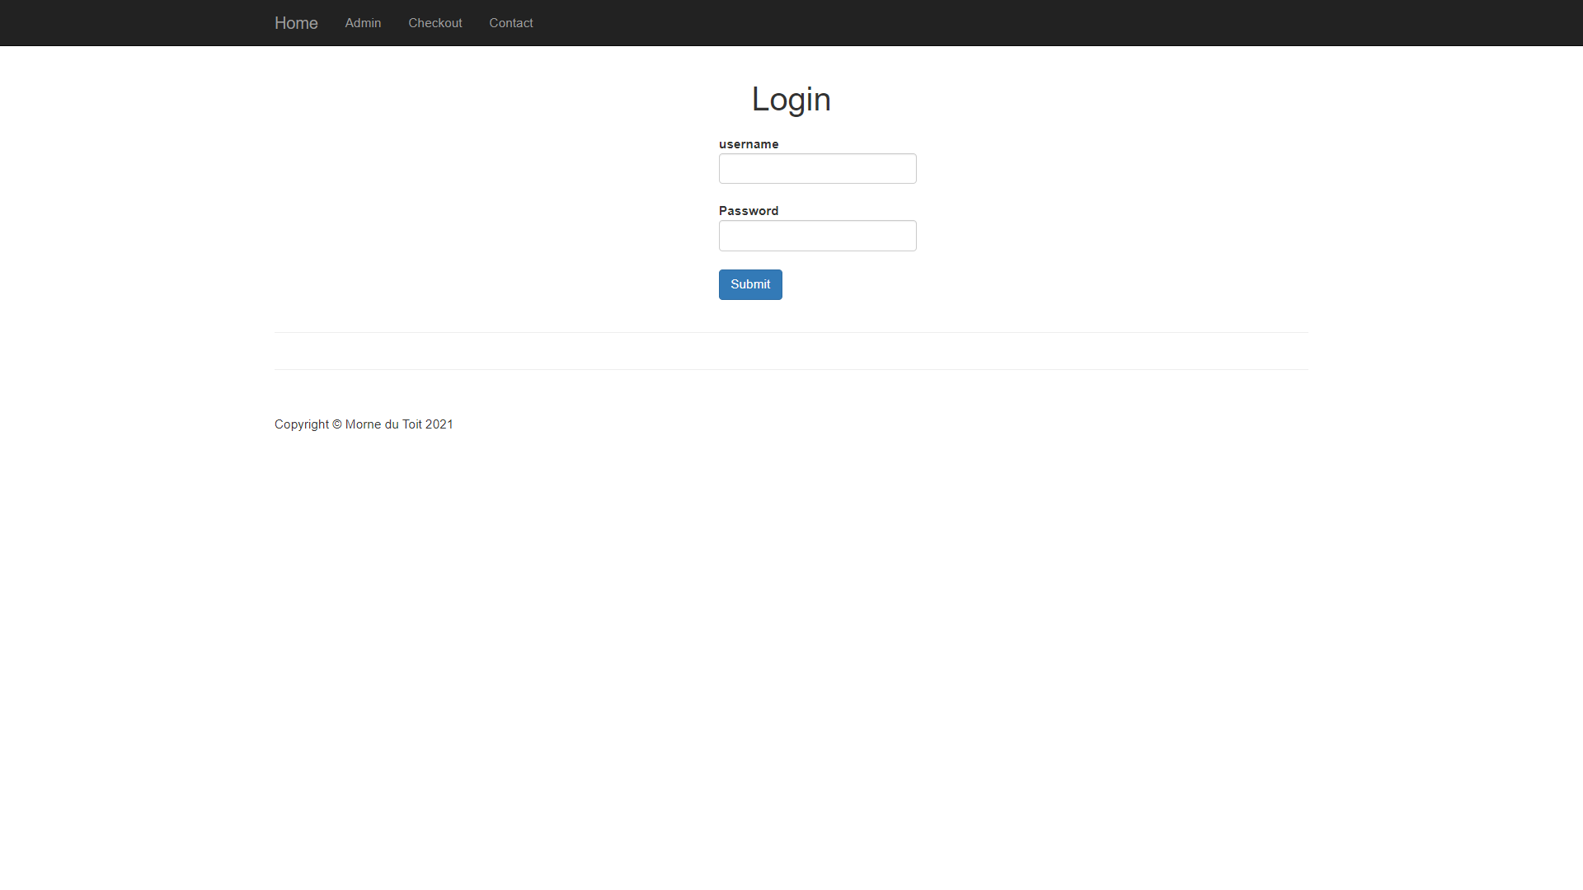

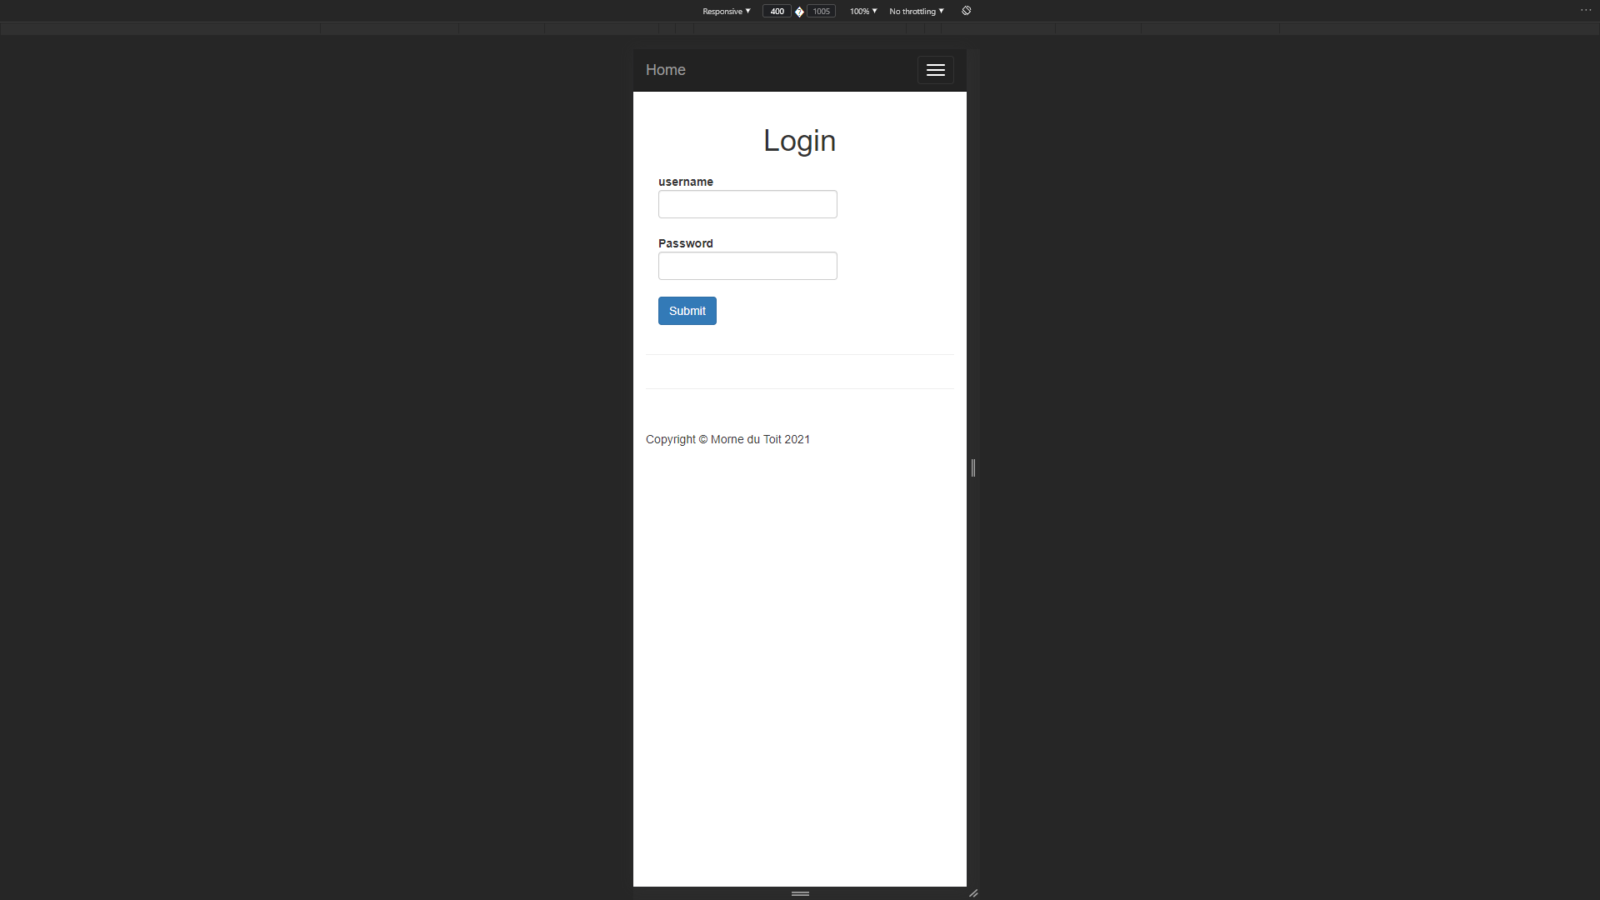

Admin

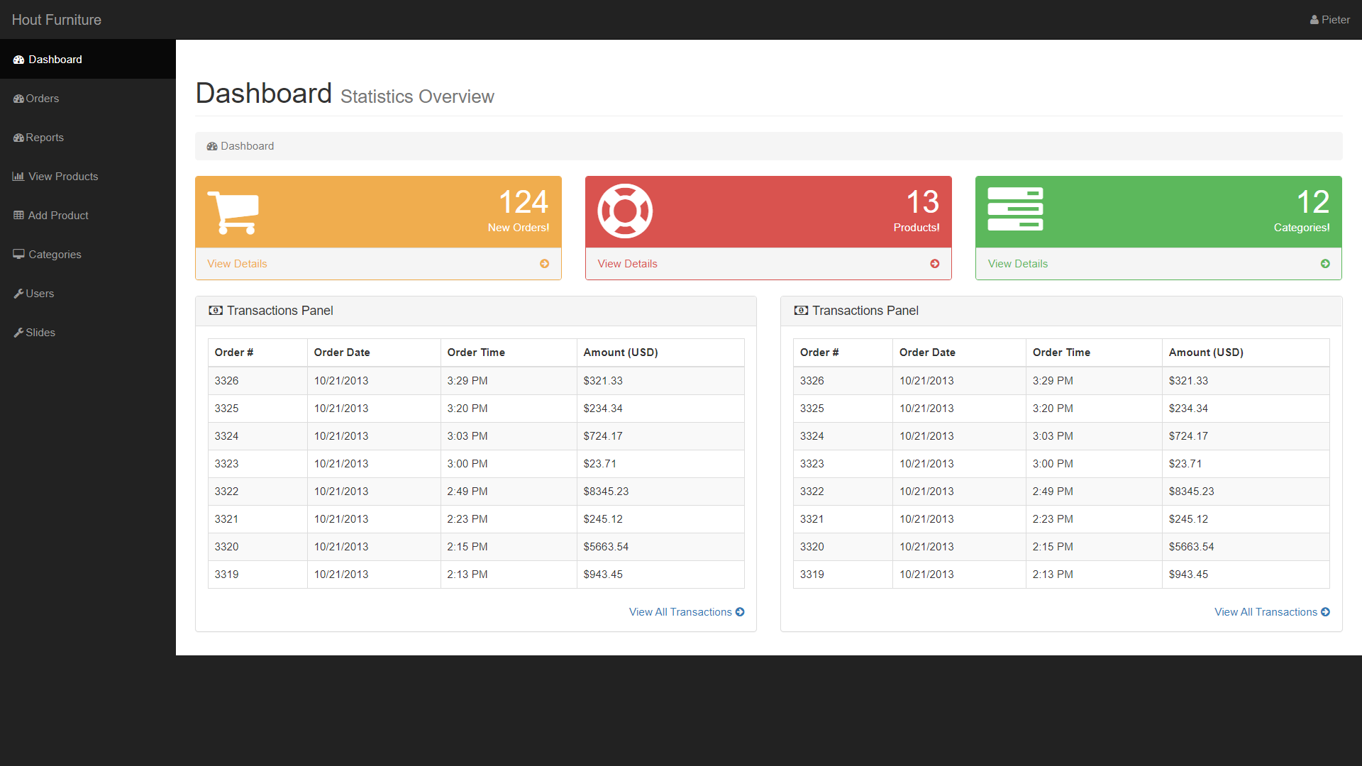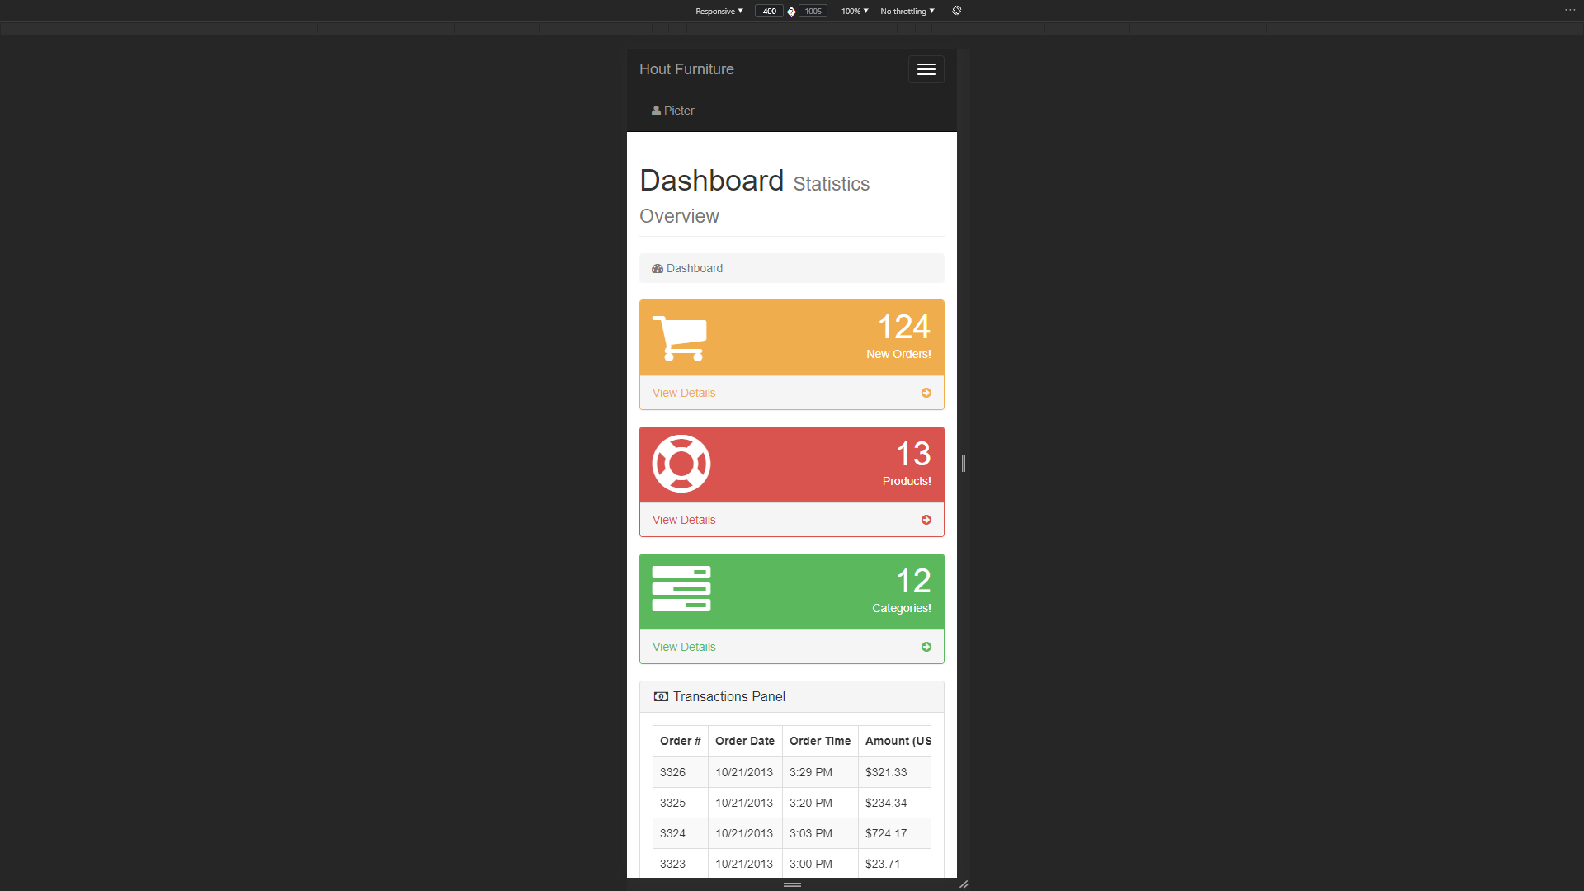

# 2.3 Designing

1. **Class Responsibility Collaboration (CRC) Cards**

| **Orders** | |
| --- | --- |
| Has an ID  Knows order amount  Knows order transaction  Knows order status  Knows order currency | Report |

| **Report** | |
| --- | --- |
| Has an ID  Knows product id  Knows order id | Product |

| **Product** | |
| --- | --- |
| Has an ID  Knows product title  Know product category id  Knows product price  Knows product quantity  Knows product description  Knows product image | Category |

| **Category** | |
| --- | --- |
| Has an ID  Know category Title |  |

| **Users** | |
| --- | --- |
| Has an ID  Knows username  Knows email  Knows password |  |

| **Slides** | |
| --- | --- |
| Has an ID  Knows title  Knows image |  |

1. **Enhanced Entity Relationship Diagram (EERD)  
   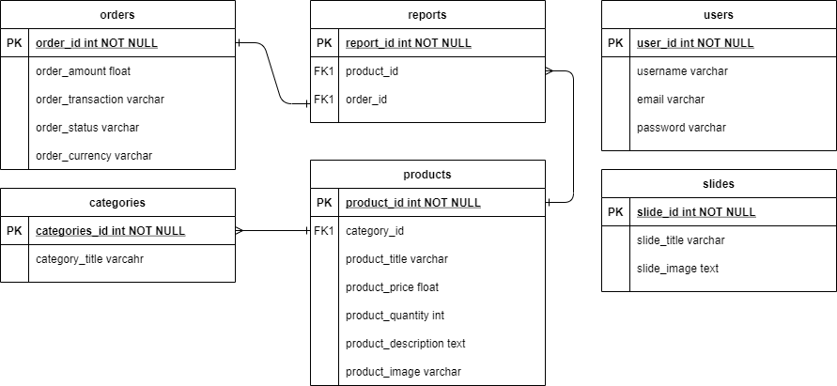**
2. **Context Diagram  
   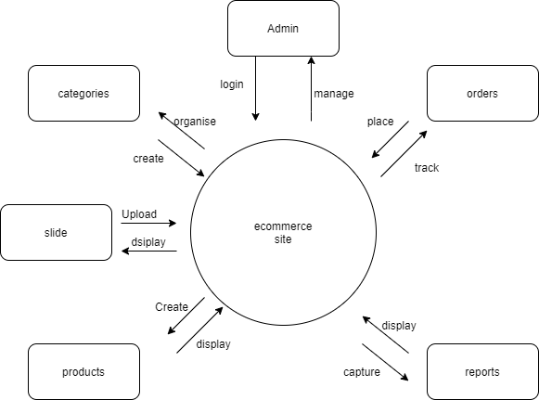**
3. **Data Flow Diagram (DFD)  
   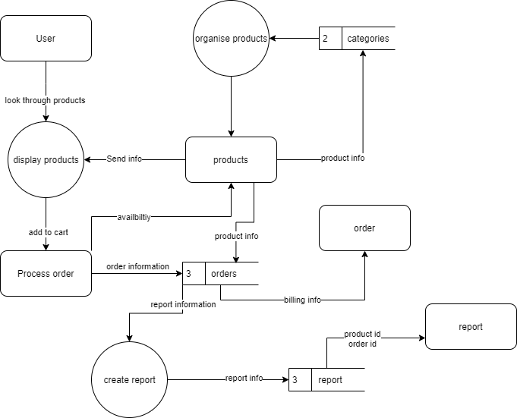**
4. **Use Case Diagram  
   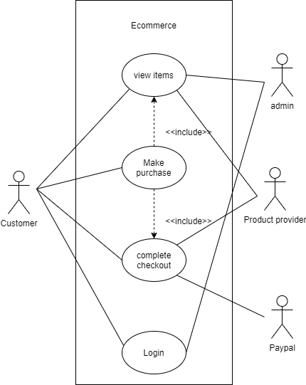**
5. **Database Design  
   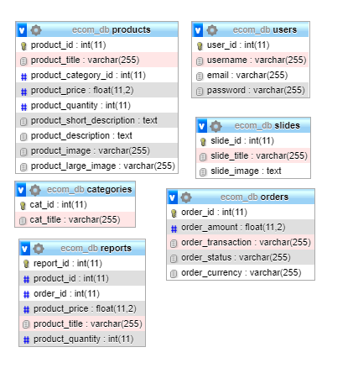**

# 2.4 Coding

Provide the screenshots and code samples of the final website. You do not have to print every code on your website. Use the following as guideline and explain what each sample code provided is used for on the website:

**a. Sample PHP Code** The following PHP code is to give more context, the code below is an extract from a file called config.php, this file is one of the most important. Since config.php is always running no matter the page, you’ve selected via including this page it ensures the following:

Firstly, start a session that keeps track of things like user login and add to cart.

Secondly is to create templates that would reduce the hassle of making a mistake when referencing specific files located within certain folders.

Thirdly, to create variables to easily log into and connect to a database, and the setup the actual database connection.

Lastly, the code requires 2 additional files namely cart.php and functions.php.

| <?php  ob_start();  session_start();  //session_destroy();  // To Make it easier to reference  defined("DS") ? null: define("DS", DIRECTORY_SEPARATOR);  defined("TEMPLATE_FRONT") ? null: define("TEMPLATE_FRONT", __DIR__ . DS . "template/front");  defined("TEMPLATE_BACK") ? null: define("TEMPLATE_BACK", __DIR__ . DS . "template/back");  defined("UPLOAD_DIRECTORY") ? null: define("UPLOAD_DIRECTORY", __DIR__ . DS . "uploads");  // For DB connection  defined("DB_HOST") ? null: define("DB_HOST","localhost");  defined("DB_USER") ? null: define("DB_USER","root"); // db username  defined("DB_PASS") ? null: define("DB_PASS",""); //db password  defined("DB_NAME") ? null: define("DB_NAME","ecom_db");  $connection = mysqli_connect(DB_HOST, DB_USER, DB_PASS, DB_NAME);  //To include these pages to every page, creating a stable connection  require_once("functions.php");  require_once("cart.php");  ?> |
| --- |

**b. Sample HTML Code**The following HTML code is to run the main index pages as mentioned above that note of the first line which requires the config.php the second line includes the header page which handles things like <!DOCTYPE html> and the links to the various stylesheets, the header also handles things like the title of the page and the top navigation.

The next part creates containers in which the main page can be built, this container is followed by a row to be able to create side navigation which in this case would be used to display the different categories.

The page then creates a column so that it is next to the side navigation, in this column firstly will be included a dynamic carousel. Underneath this carousel a function, which is required through the required config.php, which includes the products from the database into a card on the page.

At the very end of this page it is including another template namely the footer.

| <?php require_once("../resources/config.php"); ?>  <?php include(TEMPLATE_FRONT . DS . "header.php"); ?>  <!-- Page Content -->  <div class="container">  <div class="row">  <!-- Side Navigation See side_nav.php-->  <?php include(TEMPLATE_FRONT . DS . "side_nav.php"); ?>  <div class="col-md-9">  <div class="row carousel-holder">  <div class="col-md-12">  <?php include(TEMPLATE_FRONT . DS . "slider.php"); ?>  </div>  </div>  <div class="row">  <?php get_products(); ?>  </div>  </div>  </div>  </div>  <!-- /.container -->  <?php include(TEMPLATE_FRONT . DS . "footer.php"); ?> |
| --- |

**c. Sample JavaScript Code**

The following JavaScript code is to create a bunch of functions

The query function performs a query on the database.

The confirm function requires a string of errors in case the query failed.

The escape_string function escapes special characters in a string for use in an SQL statement, taking into account the current charset of the connection.

The fetch_array function fetches a result row as an associative, a numeric array, or both.

The get_products function firstly selects all of the products from the database using the query function. Thereafter, the fetch_array function fetches a result row as an associative to use in the $product variable which uses a delimiter to create HTML code meaning that when this function is called it returns not only database results but also returns an HTML format which is filled with database enquired information.

| function query($sql)  {  global $connection;  return mysqli_query($connection, $sql);  }  function confirm($result)  {  global $connection;  if (!$result) {  die("QUERY FAILED " . mysqli_error($connection));  }  }  function escape_string($string)  {  global $connection;  return mysqli_real_escape_string($connection, $string);  }  function fetch_array($result)  {  return mysqli_fetch_array($result);  }  function get_products()  {  $query = query("SELECT * FROM products");  confirm($query);  while ($row = fetch_array($query)) {  $product = <<<DELIMETER  <div class="col-sm-4 col-lg-4 col-md-4">  <div class="thumbnail">  <a href="item.php?id={$row['product_id']}"><img src="{$row['product_image']}" alt=""></a>  <div class="caption">  <h4 class="pull-right">R {$row['product_price']}</h4>  <h4><a href="item.php?id={$row['product_id']}">{$row['product_title']}</a>  </h4>  <a class="btn btn-primary" target="_blank" href="../resources/cart.php?add={$row['product_id']}">Add to cart</a>  </div>  </div>  </div>  DELIMETER;  echo $product;  }  } |
| --- |

**d. Sample CSS Code**

The following CSS code is to set the default font family and font size for all HTML. For any page containing body, the next part of the code will set the default font family as well as its size, line height, and color as well as the page’s background color.

The following affect any element within the container class by setting the container’s padding and margins.

| html {  font-family: sans-serif;  -webkit-text-size-adjust: 100%;  -ms-text-size-adjust: 100%;  }  body {  font-family: "Helvetica Neue", Helvetica, Arial, sans-serif;  font-size: 14px;  line-height: 1.42857143;  color: #333;  background-color: #fff;  }  .container {  padding-right: 15px;  padding-left: 15px;  margin-right: auto;  margin-left: auto;  } |
| --- |

**e. Sample MySQL Table Screenshots**

The website’s database has the following structure:

*ecom_db*

*categories*

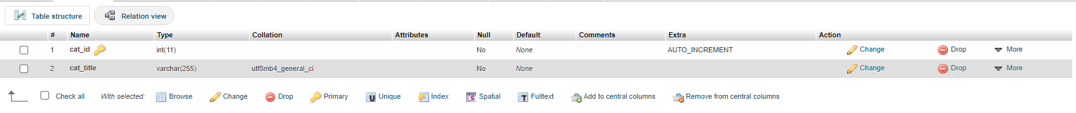

*orders 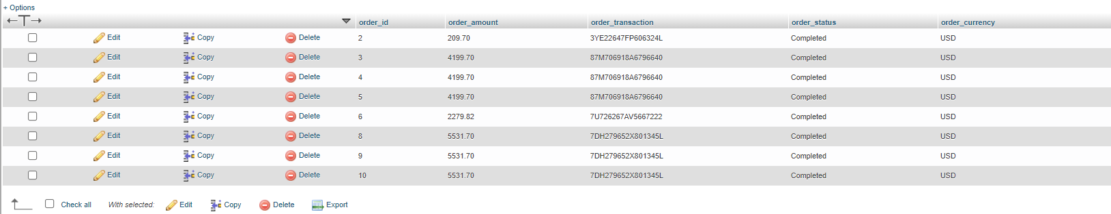*

*products*

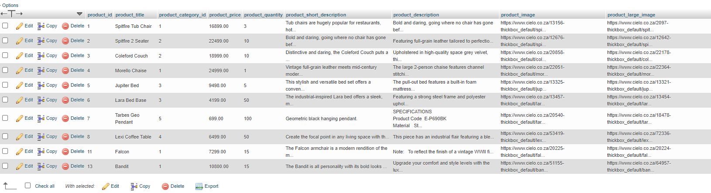

*reports*

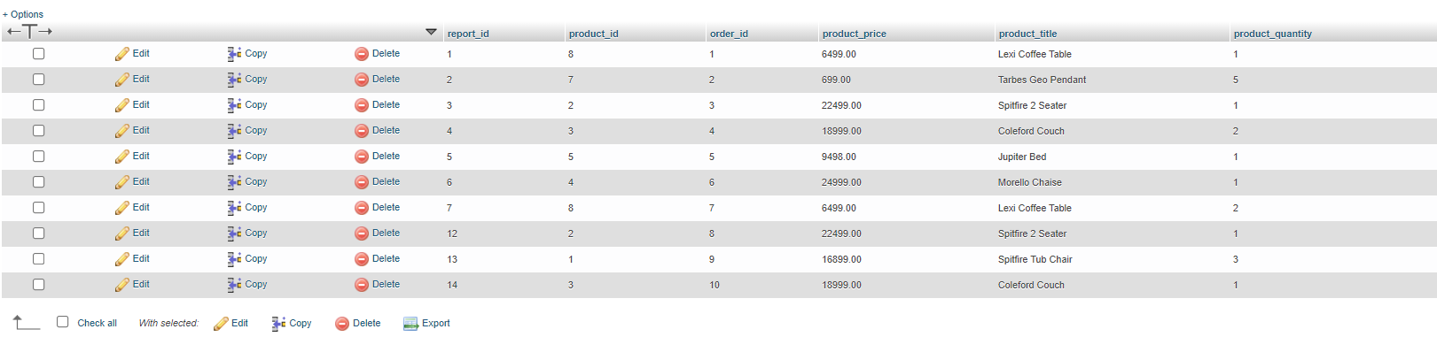

*slides*

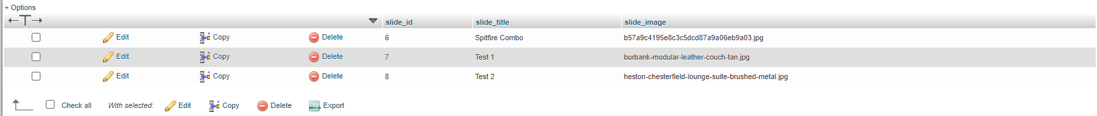

*users*

**

# 2.5 Conclusion

To conclude, an eCommerce site would be needed to sell furniture locally and globally.

The site would need serval features like:

* Role-based permissions on the website.
* The client’s customers would need to be able to create an account.
* The client’s customers would need to be able to see their history.
* A home page where clients can see the products available.
* The site would need to handle payments and order placements
* The client must be able to upload new products or remove existing ones as well as be able to edit the products
* The client would need to see a complete report of all his business activities.

All of these requirements can be completed within the time frame.

# 

# 2.6 Sign-off



|  |  |  |  |
| --- | --- | --- | --- |
| Ryan, Project Client      Date: 20 June 2021 |  |  | Morne du Toit, Project Manager      Date: 20 June 2021 |